**NAME : PRATHAPANI SATWIKA**

**REG.NO : 20BCD7160**

**EXPERIMENT NO. 3 -APPLICATIONS TO INTEGRAL CALCULUS**

**1.**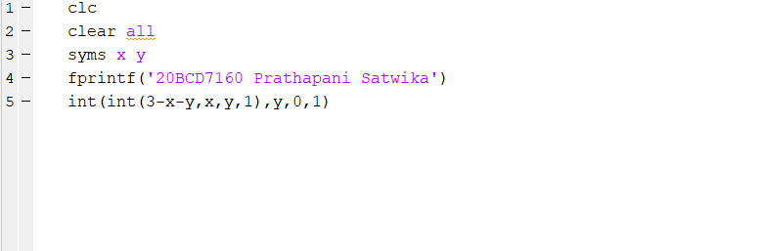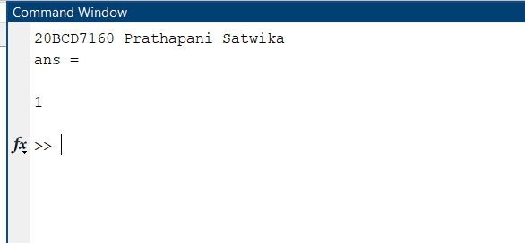

**2.**

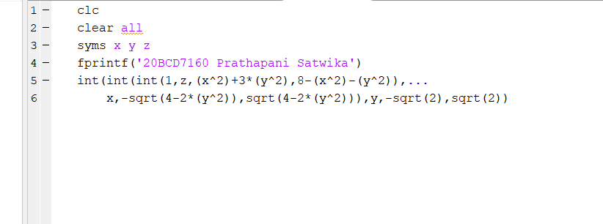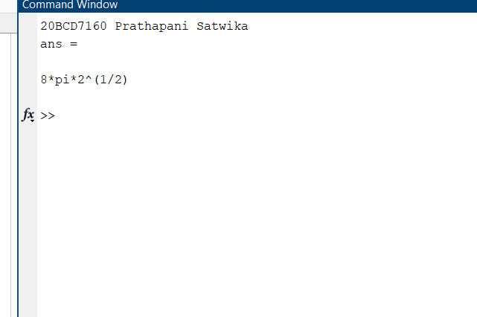

**3.**